**Quick Tutorial of EX-Converter v1.2.1**

*Author: Jack Zhang (sf.jackzhang@gmail.com)*

*Date: 15th Feb, 2013*

*Version: 1.0*

--------------------------------------------------------------------------------------------------------------------------------

When using this tool, it means that you want ot convert your existing test specifications written in Excel sheets to XML files. Then you could import them to TestLink’s “Test Specification” tree folders.

Before converting, you should note that:

1. TestLink 1.9.x supports importing your test specifications with the format of both “test suite” and “test cases”. And all those should be in XML files.
2. TestLink limits the Max. file size for importing to be 400KB.
3. EX-Converter 1.2.1 supports:
   1. Converting with both “test suite” (up to 2 levels) and “test cases”;
   2. Defining (mapping) of “Level-1-suite”, “Level-2-suite”, “Name”, “Importance”, “Summary”, “Preconditions”, “Actions” and “Expected Results.”
   3. A sigle test case that has multiple steps defined in separated Excel sheet cells. Step numbers will be assigned automatically.
4. EX-Converter 1.2.1 currently DO NOT support:
   1. Defining of test suite’s “Node Order” and “Details”. But these fields will be assigned with a default value by TestLink during importing.
   2. Defining of test case’s “Internal ID”, “Node Order”, “External ID” and “Version”. But these fields will be assigned with a default value by TestLink during importing
   3. Defining of test cases’s “Execution Type”, the converter will always assign this field as “Manul”.

Steps below shown a regular process for doing this, as example, converting with a 2-level test suite in an Excel sheet (whereas converting with test cases would be only simpler).

1. Launch EX-Converter and select “Source Excel File”, pointing to your file : “EX-Converter_Test_Suite_Templates-0_0_2.xlsx” (the standard template).
2. Select “Destination XML File” (or create new), e.g. with the name of “Sample_Test_Suite.xml”.
3. Click on “Test Suite” in “Template Type” and check with “Enable Level 2 Folder”.
4. Enter “1” into “Active Sheet”, since sheet in use is the first one of the Excel file.
5. Map other fields corresponding to your source Excel sheet. E.g. enter “16” to “Start Row”, enter “d” or “4” to “Name”. Screentshots below shown a fully mapped result of the source sheet:

*Source sheet:*

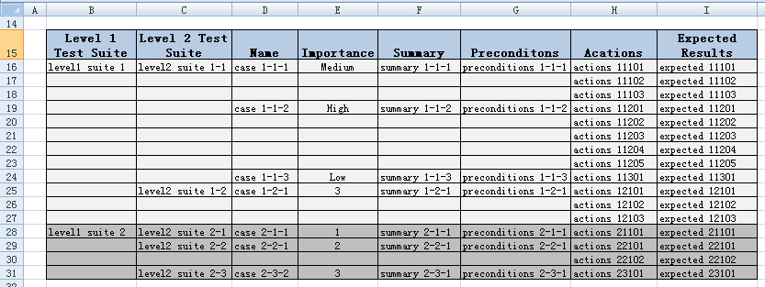

*Fully mappings:*

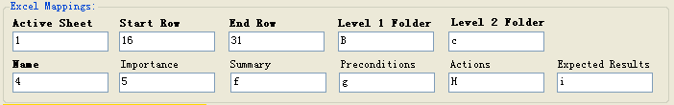

1. Convert! Then check log information if necessary.
2. Go to your TestLink web page -> “Test Specification” tab -> “Your Destination Test Suite” -> “Test Suite Operations” -> “Import” -> Choose your XML file and upload. When finished, your folders and cases results should be same with below screenshots:

*Folder structure:*

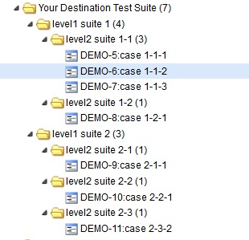

*Case contents:*

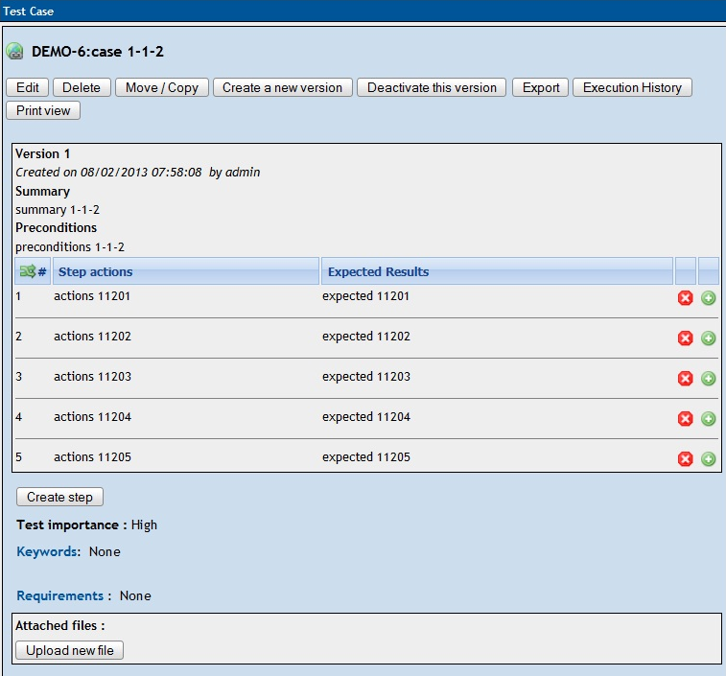

--------------------------------------------------------------------------------------------------------------------------------

For the Standard EX-Converter templates and variations, refer to files:

<EX-Converter_Test_Cases_Templates-0_0_2.xlsx>

<EX-Converter_Test_Suite_Templates-0_0_2.xlsx>

For EX-Converter project, go to SourceForge.net:

<http://sourceforge.net/projects/ex-converter/>

For TestLink resouces, go to TestLink forum:

<http://www.teamst.org/forum/index.php>